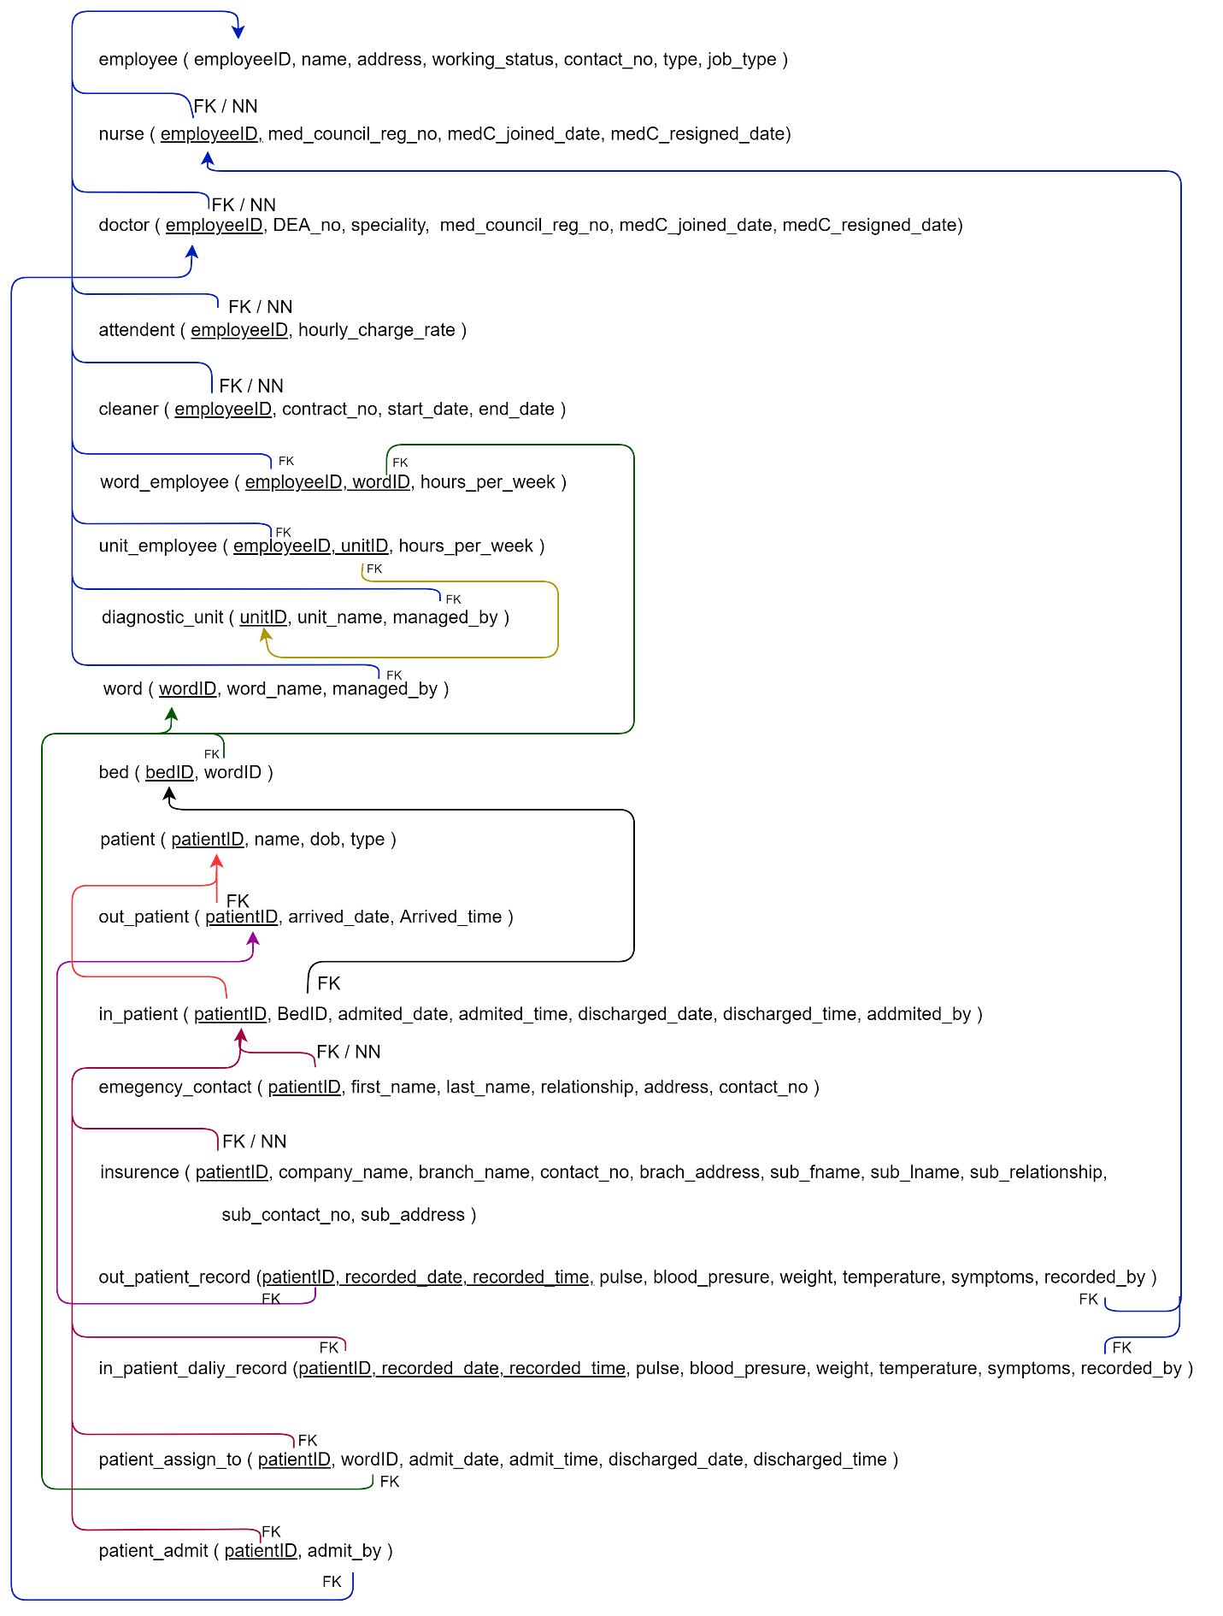

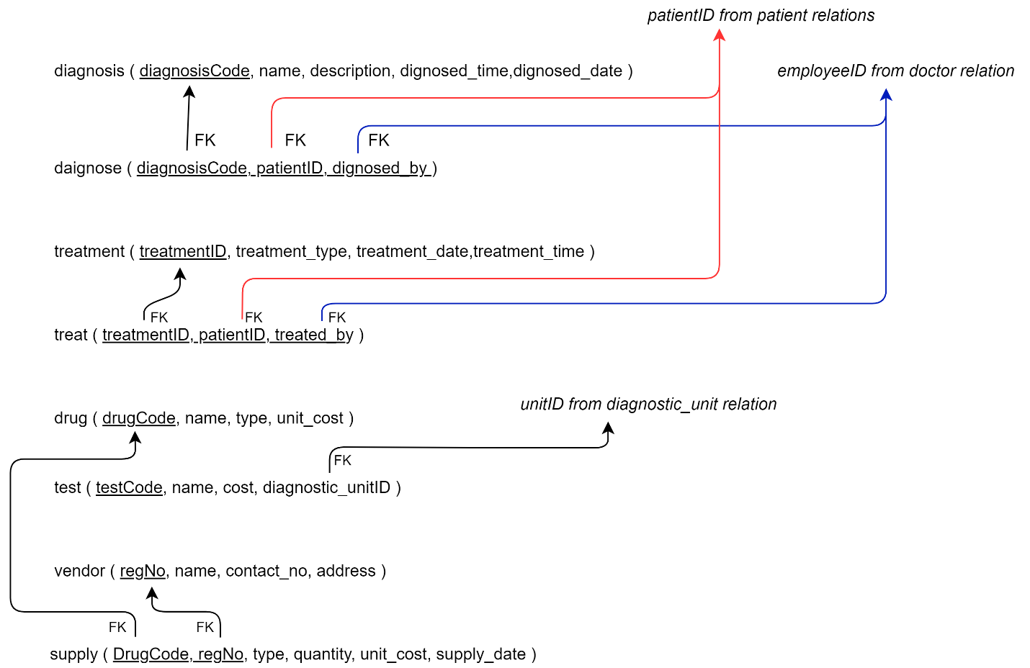

# **Assumptions**

1. Every Patient gets at least one treatment.
2. Every Patient gets diagnosed.
3. Every Patient who admitted to the hospital, gets a bed.
4. Patient personal details are recorded by nurses.
5. In-patient and Out-patient Report are stored in two separate tables.
6. insurance_no in insurance relation and treatmentID in treatment relation are added to identify the each record.